**MIS631 - Data Management**

**Project Report**

**Inventory Management System**

Group1(Rafiuddin Mohammed, Ankith Prakash, Bhavana Jayaram, Jusak Praveen sikkaram, prameela Rani Vakkala Gadda,

Hao Wang)

**Inventory Management System**

**Abstract**

The Inventory Management system is a web based system that tracks and reports inventory of items across a group of stores. It helps in tracking the items, comparing it with the sales and then optimizing the points to reach desired sales. A good inventory management system is a must for any business. It’s critical for businesses to track stock levels and manage it efficiently. Without an effective inventory system, you're missing out on opportunities to maximize profits and reduce waste. While there are several different types of inventory management systems, sometimes all you need is just a simple product tracker so you can keep track of new items arriving into your warehouse or storeroom, or those that you need to order with your suppliers.

Inventory management systems control space, time and product availability at every stage of the manufacturing process to help minimize downtime and production inefficiencies. Inventory management software is ideal for all types of retailers, from small shops to large chain stores. It supports all retail warehouses, which means that you can use the software’s management features to increase sales and profits from your business.

Supply Chain is becoming more and more critical to many businesses. The fulfilment of supply chain activities requires the development and effective management of a wide range of information, including inventory data and product movement, supplier credits and claims, vendor performance metrics and expense reporting as well as customer orders.

A complete SQL query is written to update and modify the stock and generate invoice. With this we can get an update whether a particular item is in stock or needs to be reordered. We can also have all the customer details which can be very useful in the future as it can be tracked to know the personal preferences of the customer and provide better recommendations in future when it is developed.

This also helps in keeping a high inventory turnover ratio to ensure our products aren't spoiling, becoming obsolete for our working capital. It'll help us to calculate how many times inventory sells in a year and see where we can make better use of our resources.

**Business Problems**

Stock-outs are more likely in businesses that do not use inventory management software, which is where inventory management software can help. Stockouts can result in late deliveries and unhappy customers. Inventory management considers all potential factors and fluctuations and issues stockout warnings in advance. This leads to improved customer experiences, which leads to increased sales.

Customer expectations are always changing. As a result, while too many stocks can result in obsolete inventory, too few stocks can prevent you from filling customer orders.

Having an order strategy that allows you to predict and fulfill demand is advantageous.

One of the most common issues with effective inventory management is overselling a product and running out of inventory. While seasonal and historical data can aid in order prediction, logistics inventory management necessitates the use of software. Inventory management software for businesses addresses these perplexing issues.

**Materials and Methods**

Depending on the type of business or product being analyzed, a company will use various inventory management methods. Some of these management methods include just-in-time (JIT) manufacturing, materials requirement planning (MRP), economic order quantity (EOQ), and days sales of inventory (DSI). There are others, but these are the four most common methods used to analyze inventory.

### **1. Just-in-Time Management (JIT)**

This manufacturing model originated in Japan in the 1960s and 1970s. Toyota Motor (TM) contributed the most to its development. The method allows companies to save significant amounts of money and reduce waste by keeping only the inventory they need to produce and sell products. This approach reduces storage and insurance costs, as well as the cost of liquidating or discarding excess inventory.

JIT inventory management can be risky. If demand unexpectedly spikes, the manufacturer may not be able to source the inventory it needs to meet that demand, damaging its reputation with customers and driving business toward competitors. Even the smallest delays can be problematic; if a key input does not arrive "just in time," a bottleneck can result.

### **2. Materials Requirement Planning (MRP)**

This inventory management method is sales-forecast dependent, meaning that manufacturers must have accurate sales records to enable accurate planning of inventory needs and to communicate those needs with materials suppliers in a timely manner. For example, a ski manufacturer using an MRP inventory system might ensure that materials such as plastic, fiberglass, wood, and aluminum are in stock based on forecasted orders. Inability to accurately forecast sales and plan inventory acquisitions results in a manufacturer's inability to fulfill orders.

### **3. Economic Order Quantity (EOQ)**

This model is used in inventory management by calculating the number of units a company should add to its inventory with each batch order to reduce the total costs of its inventory while assuming constant consumer demand. The costs of inventory in the model include holding and setup costs.

The EOQ model seeks to ensure that the right amount of inventory is ordered per batch so a company does not have to make orders too frequently and there is not an excess of inventory sitting on hand. It assumes that there is a trade-off between inventory holding costs and inventory setup costs, and total inventory costs are minimized when both setup costs and holding costs are minimized.

### **4. Days Sales of Inventory (DSI)**

This financial ratio indicates the average time in days that a company takes to turn its inventory, including goods that are a work in progress, into sales. DSI is also known as the average age of inventory, days inventory outstanding (DIO), days in inventory (DII), days sales *in* inventory or days inventory and is interpreted in multiple ways.

Indicating the liquidity of the inventory, the figure represents how many days a company’s current stock of inventory will last. Generally, a lower DSI is preferred as it indicates a shorter duration to clear off the inventory, though the average DSI varies from one industry to another.

The Data Modeling Tool which we used for this project is Erwin Data Modeler. It is an industry leading tool for visualizing metadata and database schema to understand complex data sources and design and deploy new ones. The Database and Query Language which we used for this project are pgAdmin and PostgreSQL.

In the project we have used 10 tables and those are as follows:

1.inv user

2.Categories

3.Products

4. Stores

5. Providers

6. Customer cart

7. Select _ product

8. Transaction

9. Invoice

10. Brands

**High Level Conceptual Design:**

Conceptual models are useful for talking at a high level about business entities and how they relate to each other. It is a concise description of the data requirements of the users and includes detailed descriptions of the entity types and relationships.

**ER Diagram:**

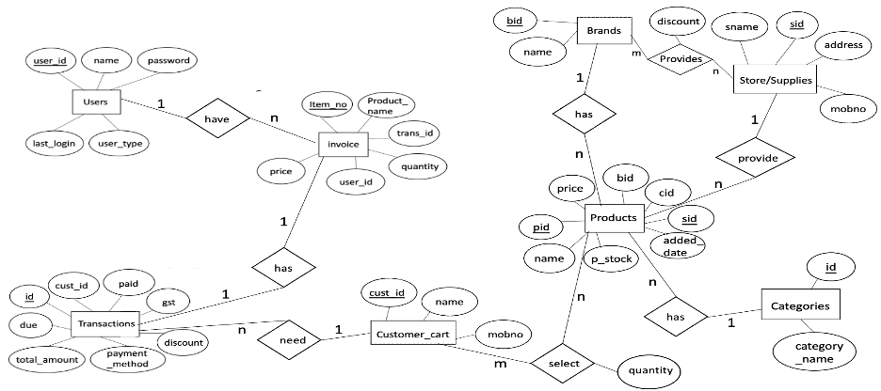

This is an ER Diagram of inventory.

We can see that there are 8 entities. For brands and suppliers, a brand is offered by multiple suppliers, and a supplier can provide many brands, so their relationship is many to many.

For brands and products, a brand has many products, and a product belongs to only one brand, so their relationship is one to many.

For supplies and products, a supplier can provide many products, and a product can only be supplied by one supplier, so their relationship is one to many.

For products and categories, a product has only one category, and a category has many products, so their relationship is one to many.

For products and customer_cart, a product can only be chosen by one consumer, and a customer can select many products, so their relationship is one to many.

For customer_cart and transactions, a consumer can have many transactions, and one transaction belongs to only one consumer, so their relationship is one to many.

For transactions and invoice, a transaction has one invoice, and one invoice corresponds to only one transaction, so their relationship is one to one.

For invoice and users, an invoice can only be owned by one user, and a user can have many invoices, so their relationship is one to many.

**Logical Dimension Model**

**Star Schema of Inventory:**

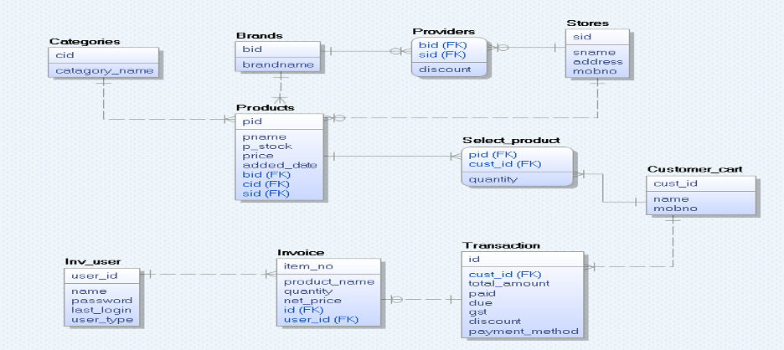

This is a Star Schema of Inventory drawn by Erwin.

In this star schema, for the product table, there are 8 attributes which are pid, pname, p_stock, price, added_date, bid, cid, sid, where pid is the primary key, and bid, cid, and sid are foreign keys respectively referenced from Brands, Categories, and Stores.

For the categories table, there are 2 attributes which are cid and category_name, where cid is the primary key.

For the brands table, there are 2 attributes which are bid and brandname, where bid is the primary key.

For the providers table, there are 3 attributes which are bid, sid and discount. Among them, bid and sid are composite primary keys, and they are also foreign keys referenced from Brands and Stores respectively.

For the stores table, there are 4 attributes which are sid, sname, address and mobno, where sid is the primary key.

For the select_product table, there are 3 attributes which are pid, cust_id and quantity. Among them, pid and cust_id are composite primary keys, and they are also foreign keys referenced from products and customer_cart respectively.

For the customer_cart table, there are 3 attributes which are cust_id, name and mobno, where cust_id is the primary key.

For the transaction table, there are 8 attributes which are id, cust_id, total_amount, paid, due, gst, discount, payment_method, where id is the primary key, and cust_id is foreign key referenced from customer_cart.

For the invoice table, there are 6 attributes which are item_no, product_name, quantity, net_price, id and user_id, where item_no is the primary key, and id and user_id are foreign keys respectively referenced from transaction and inv_user.

For the inv_user table, there are 5 attributes which are user_id, name, password, last_login and user_type, where user_id is the primary key.

**Keys and Constraints**

SQL constraints are used to specify rules for the data in a table. These rules ensure the accuracy and reliability of the data in the table. If there is any violation between the constraint and the data action, the action is aborted.

**Primary Key**: A primary key is the column or columns that contain values that uniquely identify each row in a table. A database table must have a primary key for efficient insertion, updating, or deleting data from a database table

**Foreign Key:** A foreign key is a column or group of columns in a relational

database table that provides a link between data in two tables. It is a in one

table, that refers to the PRIMARY KEY in another table.

**Query Tool**

The Query Tool is a powerful, feature-rich environment that allows you to execute arbitrary SQL commands and review the result set. You can access the Query Tool via the *Query Tool* menu option on the *Tools* menu, or through the context menu of select nodes of the Browser tree control. The Query Tool allows you to:

* Issue ad-hoc SQL queries.
* Execute arbitrary SQL commands.
* Edit the result set of a SELECT query if it is [updatable](https://www.pgadmin.org/docs/pgadmin4/latest/query_tool.html#updatable-result-set).
* Displays current connection and transaction status as configured by the user.
* Save the data displayed in the output panel to a CSV file.

**Solutions and Results**

This section gives a overview on the code we used to create the tables and retrieve the data in the tables.

For insertion of the data we used the **PgAdmin4**

**Brands Table:**

**User Table:**

**Categories Table:**

**Products Table:**

**Stores Table:**

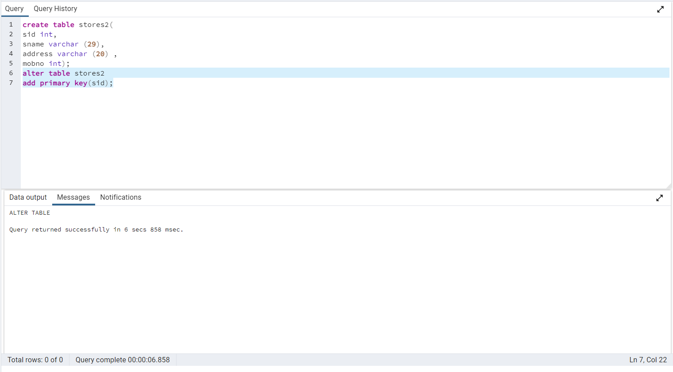

**Provide Table:**

**Customer Cart table:**

**Product Table:**

**Transaction Table:**

**Invoice Table:**

**Views:**

Views in SQL are kind of virtual tables. A view also has rows and columns as they are in a real table in the database. We can make a view by selecting fields from one table.

There are one or more tables in the database. A View can contain either all of the rows of a table or specific rows based on a condition.

Views help us limit data access, hide data complexity (joins), simplify commands for the user, and store complex queries.

**Query Table:**

A query tree is a tree data structure representing a relational algebra expression.

The query tables are represented as leaf nodes. The internal nodes represent the relational algebra operations. The root represents the entire query.

**Conclusion:**

Let’s conclude the topic at last.

In this project we have created a complete back-end software in which we can update the stock, modify the stock, we can forecast the stock, and generate an invoice.

From the application, we can get an update that if a particular inventory or stock is less than some pre-fixed quantity then it will be easy for the manager/owner to record the product from the supplier to overcome the “Out of Stock” stage.

In addition to this, it can also help us to manage the warehouses, and add warehouses which can be proven as a very useful feature.

We can have complete customer details which can help us retrieve regular customers' order details.

From this program, we can also keep a track of transactions performed by different customers/clients. We can also get an idea of how much funds we received from different payment methodologies.

Inventory Management is a very complex but essential part of the supply chain. An effective inventory management system helps to reduce stock-related costs such as warehousing, carrying, and ordering costs.